Question 1

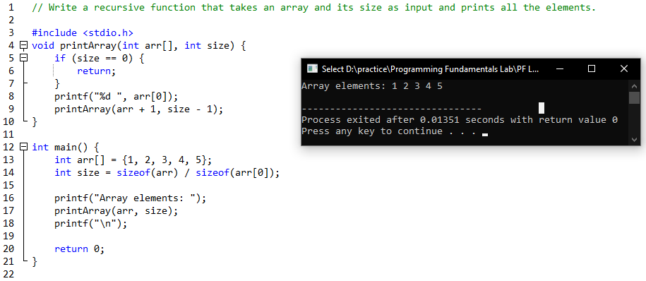

Question 2

Question 3

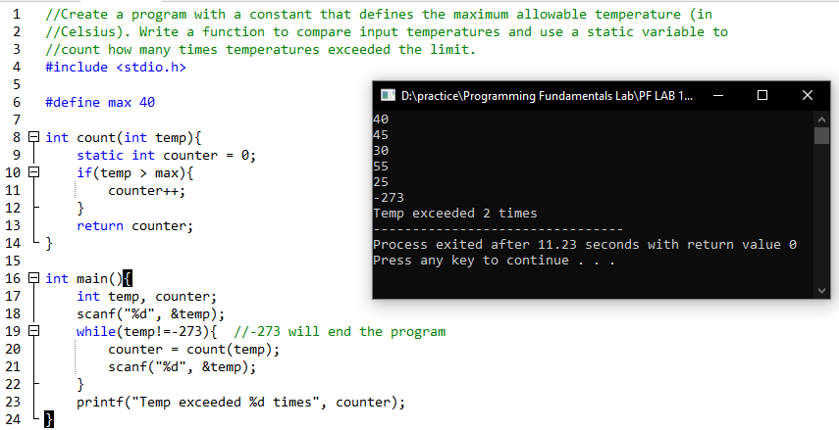

Question 4

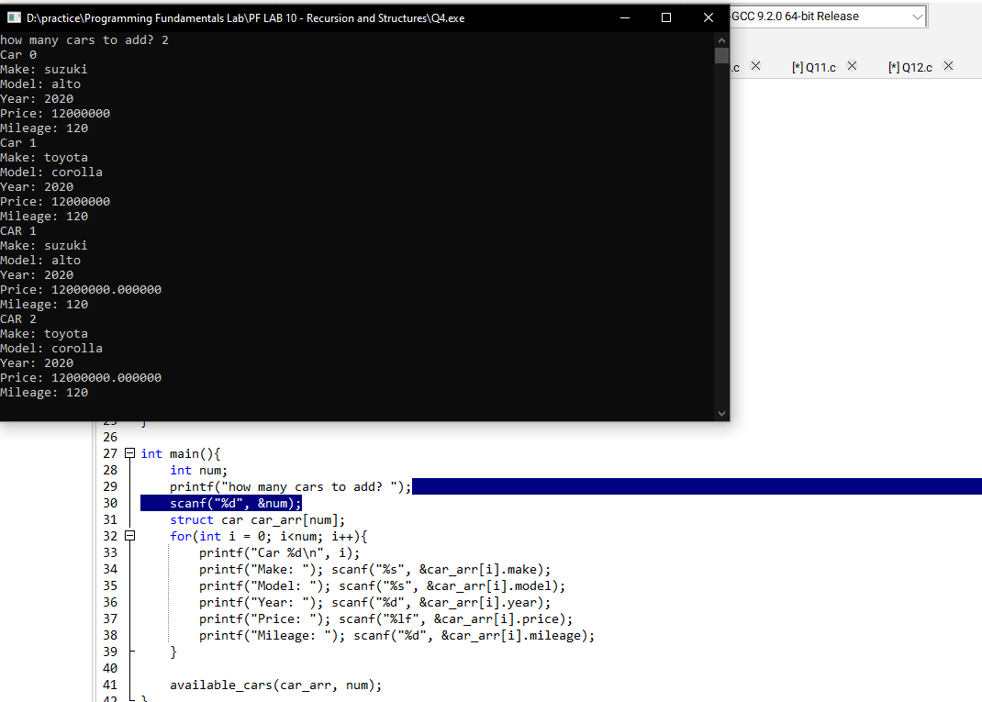

Question 5

Question 6

Question 7

Question 8

Question 9

Question 10

Question 11

Question 12

